1. 选择你想导出的column

Machine generated alternative text:
《Vector〔厶Ndb和和Editor-0\0〕EESE\NetCom\D3Coredatabase\Y2021FNV3CMD8v21£2\Y2D21FNV3CMD8v21£2HS3V2.dbc．[Ove阉
+卜FileEditViewOptionsWindowHelp
囗N陶or
王豐ECL's
〈EnvironmentV凸
闩N陶or疑nodes
闩厶剛MCIM
囗歪」TxMessages
囗歪」Messages
`MTXSignals
王MappedSignals
王厶剛MCISM
田气．GENERIC
tfi
Nam
0
N陰匚匚[ny一8一Rq》p匚
NAccEnbI_8_RqDrv
〔M8eItminde凵diost
N〔MCurrentHDMuIticastSt
N〔MCurrentSSName
N〔MHDChanStatus
N〔MHDModeStatus
N〔MR8DSMode
N〔MStationListScanSt
NACM_TagMode
N厶（N8监匚
NN凵dioDStat
NActvNseMute_D_Rq
N〔UActChimeType_St
N〔UActChimeTypeDat_St
Message
Cluster《nfol
Cluster《nfol
AHIJStatusMessage
厶〔MSendSignals
监〔MSendSignals
监〔MSendSignals
厶〔MSendSignals
监〔MSendSignals
厶〔MSendSignals
厶〔MSendSignals
监匚teNoise
厶匚teNoise
ActiveNoise
监〔USend_Signals。
厶〔USend_Signals_

1. File ->Export-> Export List of Objects..

Machine generated alternative text:
《Vector〔厶Ndb和和Editor-0\0〕EESE\NetCom\D3Coredatabase\Y2021FNV3CMD8v21£2\Y2D21FNV3CMD8v21£2HS3V2.dbc．[OveView
FileEditViewOptionsWindowHelp
CreateDatabase
OpenDatabase
Saveas.
Export
mpotAttributeDefinitions...
ConsistencyCheck
ExecuteScript..
Y2D21FNV3CMD8v21£2HS3V2.dbc
2Y2D21FNV3CMD8v21£2HS3.dbc
彐Y2D21FNV2〔M[吧v21£2HS3.dbc
4Y2D21FNV3CMD8v21£1HS3VI(2).dbc
5HS3〔厶N〔x727BEVMY21DCVV22.dbc
6HS3〔厶N〔x727BEVMY21DCVV22.dbc
7Y2D21FNV2〔M[吧v21£2HS3vIO.dbc
8Y2020FNV2CMD8v201彐HS2.dbc
gY2020FNV3CMD8v20.04HS3.dbc
10HS3〔厶N〔D2GASMY21〕gdb匚
Ctrl+N
〔trl和0
Nam
N陰匚匚[ny一8一Rq》p匚
NAccEnbI_8_RqDrv
〔M8eItminde凵diost
《ntoCANdbNor疑Files.
ExportListofObjects.
NACMHDM0deStatu
N〔MR8DSMode
N〔MStationListScanSt
NACM_TagMode
N厶（N8监匚
NN凵dioDStat
NActvNseMute_D_Rq
N〔UActChimeType_St
N监〔刂ActChimeTypeDat_St
N
4辶」4:tSavi•:eLink欧
N厶〔UAF」ump_St
N厶〔UAFModeSt
N〔U陰R厶凵dioSo凵e一p
N〔UAROperationType_Rsp
N〔UARReqstrPriority_Rp
N〔UARReqstrSystem_Rsp
Message
Cluster《nfol
Cluster《nfol
AHIJStatusMessage
厶〔MSendSignals
监〔MSendSignals
监〔MSendSignals
厶〔MSendSignals
监〔MSendSignals
厶〔MSendSignals
厶〔MSendSignals
监匚teNoise
厶匚teNoise
ActiveNoise
监〔USend_Signals。
4〔刂Send_Signals
4辶」SencLSignelG_
监〔USend_Signals_8
厶〔USend_Signals
监〔UResponse_Sig„
厶〔UResponse_Sig•
厶〔UResponse_Sig„
监〔UResponse_Sig„
Multiplexing/••
Startbit

1. Save as APIM\_CIM\_Tx\_2102.csv
2. Open the APIM\_CIM\_Tx\_2102.csv

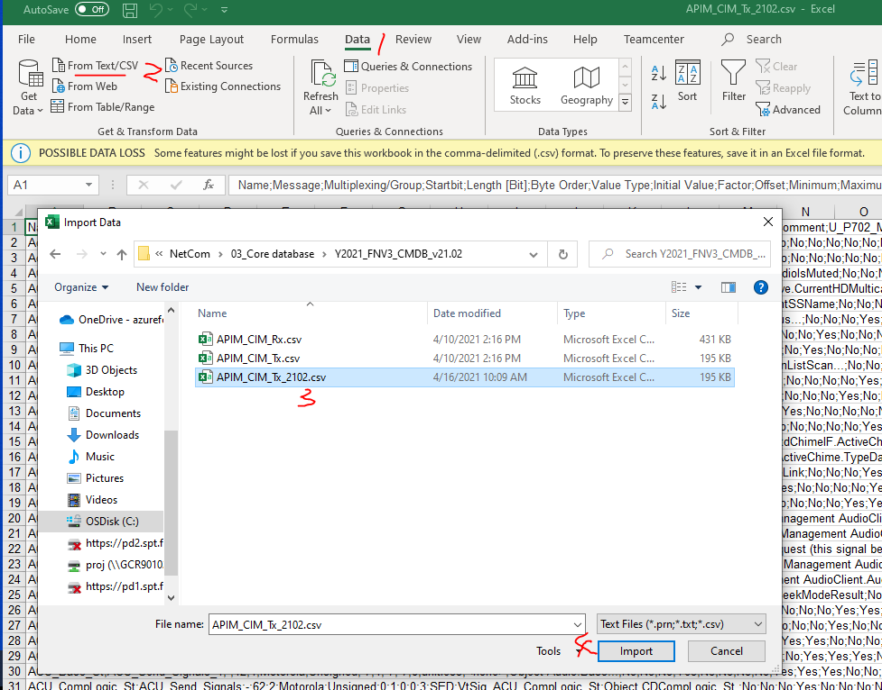

5. Delimiter ->choose Semicolon->load

Machine generated alternative text:
APIMCIMTx2℃2℃sv
FileOrigin
1252：WesternEuropean(Windows)
Delimiter
Multiplexing/6roup
D已TypeDetection
83donfirst20〕rows
Startblt
Length[BIO
0
Value
Name
AccDeny_a_Rqlpc
ACCEnbl_3_RqDrv
Cluster》MOI
Cluster》MOI
AHLISt蘸usMessage
ACM
ACM
ACM
ACM
ACM
ACM
ACM
BeltminderAudiOSt
CurrentHDMultiGStSt
CurrentSSName
HOChanStatus
HOMOdeStatus
R3D5M00巴
StationLi5tScanSt
ACM_TagMOde
ActVNse巳Actv
ActVNseAudiOD蘸
ActVNseMute_D_Rq
ACL'ActChimeTvpe_St
ACL'ActChimeTvpeDat
ACL'ActServiceLinkSt
ACL'AFJump_St
ACL'AFModeSt
ACL'ARAudiOSource_Rsp
ACL'AROperationTvpe_Rsp
ACM
ACM
ACM
ACM
ACM
ACM
ACM
Send
Send
Send
Send
Send
Send
Send
gn引5
gn引5
gn引5
gn引5
gn引5
gn引5
gn引5
ActiveNoise
ACL]
ACL]
ACL]
ACL]
ACL]
ACL]
ACL]
Send&昙n引5
Send&昙n引5
5nd5唁n引5
Send&昙n引5
Send&昙n引5
14
14
10
14
ResponseSignals
ResponseSignals
ByteOrder
Motorola
Motorola
Motorola
Motorola
Motorola
Motorola
Motorola
Motorola
Motorola
Motorola
Motorola
Motorola
Motorola
Motorola
Motorola
Motorola
Motorola
Motorola
Motorola
Motorola
ValueType
Unsigned
Unsigned
Unsigned
Unsigned
Unsigned
Unsigned
Unsigned
Unsigned
Unsigned
Unsigned
Unsigned
Unsigned
Unsigned
Unsigned
Unsigned
Unsigned
Unsigned
Unsigned
Unsigned
Unsigned
TransformD已
GENE
Y202£
丁On《
0．No
No-No
No-N
No-Ye•
Yes
No-No
Yes陆
nChar
No-N(
sNo
No-NI
sNo
No-NI
0．No
Yes
0．No
sNo
No-Ye
0．No、
No-No
丁No
YesNI
o-0x0
No-Nc
No-NI
No№

1. Save as excel file.